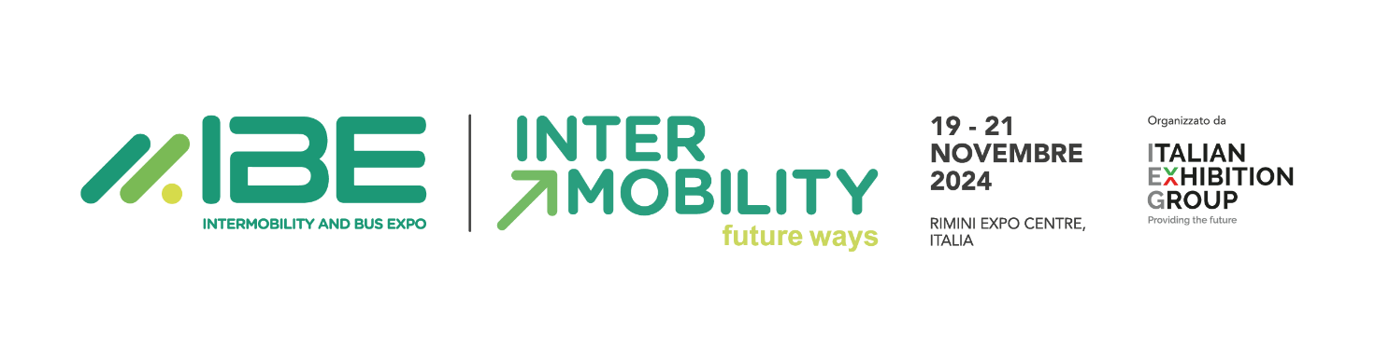
press release 4

IBE 2024:
THE GREEN JOBS & SKILLS PROJECTS GETS UNDERWAY TO BRIDGE COMPANIES’ EMPLOYMENT GAP AND BRING BACK FIELD TRAINING

- The Italian Exhibition Group event running at Rimini Expo Centre from 19 to 21 November will be a job-dating and in-depth platform connecting supply and demand for green jobs
- “Electric Bus Driver Training” is back, the programme that prepares drivers for electric vehicles and the IBE Test Drives

Rimini, 19-21 November 2024 – An innovative model to create employment opportunities in collective transport and shared mobility. IBE Intermobility and Bus Expo, the event curated by Italian Exhibition Group, will host its 11th edition at Rimini Expo Centre from 19 to 21 November, as a meeting point between the industry’s job supply and demand, introducing Green Jobs & Skills, a project that includes a platform dedicated to “job-dating” and a day dedicated to deep dives into the topic.

A MODEL ENCOURAGING GREEN JOBS
The Green Jobs & Skills project, scheduled for Thursday, November 21, is part of a wider programme of activities related to innovation promoted by IBE Intermobility and Bus Expo that will be held at the Innovation District. Coordinated by journalist and populariser Marco Gisotti, it will be a valuable opportunity for training and professional orientation for recent graduates, school leavers, young professionals and workers interested in approaching the world of sustainability, but also an opportunity for companies to meet potential candidates and intercept the most promising talents via the event’s official app.
“Green jobs and training for the transport of people” is a training course dedicated to young people and will focus on adapting the school offering to the new professions related to shared sustainable mobility, followed by an orientation talk.
This project includes the first national meeting on employment and training for passenger transport: IBE will hold a discussion between institutions and experts to learn about the training offer in Italy and steer young people towards jobs in the industry.

According to Unioncamere data, 3.9 million new workers with sustainability-related skills will be needed in the next five years, with 65% of these required at an intermediate level and 41% at a high level. One of the most affected sectors is public passenger transport, where 16,000 new drivers for buses, trams and undergrounds are immediately required, both in public and private transport. In addition to orienting the job market, the project intends to promote the importance of public transport as a solution to significantly reduce CO2 emissions: travelling by private car, in fact, can generate up to 80% more emissions per kilometre than public transport.

TRAINING: MOVING TOGETHER TOWARDS THE FUTURE OF SUSTAINABLE MOBILITY
After the success of the last edition, “Electric Bus Driver Training” returns to IBE 2024: organised by IBE and Addestra, in collaboration with EVAcademy, Efficient Driving and Pullman magazine, the programme prepares drivers for the transition to driving thanks to the support of IVECO BUS, who will provide vehicles from the electric range.
The topic of training is also at the heart of the conference organised by AN.BTI Confcommercio “Professionalism, free time and salaries: the evolution of the figure of bus driver into that of 'Bus Manager” which aims to focus attention on a factor such as staff recruitment.
“The change in the organisation of bus manufacturers and TPL operators driven by sustainability”, curated by Andrea Bottazzi, maintenance manager engineer of TPER, will analyse the sustainable evolution of the organisations of bus manufacturers and local public transport operators.

IBE 2024 –GREEN JOBS&SKILLS PROJECT
https://en.expoibe.com/ibe/special-initiatives/innovation-district/green-jobs-skills

PRESS CONTACT - ITALIAN EXHIBITION GROUP
head of media & corporate communication: Elisabetta Vitali; press office manager: Marco Forcellini, Pier Francesco Bellini; international press office coordinator: Silvia Giorgi; press office coordinator: Luca Paganin; press office specialists: Nicoletta Evangelisti, Mirko Malgieri; media@iegexpo.it

MEDIA AGENCY
Twister communications group
Patrizia Vallecchi, +39 335 6334169 - pvallecchi@twistergroup.it
Monica Cipparrone - +39 349 2814894 – mcipparrone@twistergroup.it
Andrea Franceschi - +39 3357485194 - afranceschi@twistergroup.it

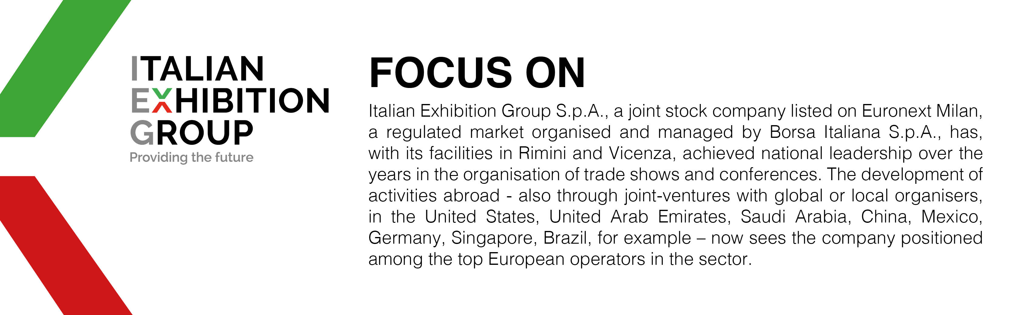

This press release contains forecast elements and estimates that reflect the management’s current opinions (“forward-looking statements”), particularly regarding future management performance, realization of investments, cash flow trends and the evolution of the financial structure. For their very nature, forward-looking statements have a component of risk and uncertainty, as they depend on the occurrence of future events. The effective results may differ (even significantly) from those announced, due to numerous factors, including, only by way of example: food service market and tourist flow trends in Italy, gold and jewellery market trends, green economy market trends; the evolution of raw material prices; general macroeconomic conditions; geopolitical factors and evolutions in the legislative framework. Moreover, the information contained in this release does not claim to be complete, and has not been verified by independent third parties. Forecasts, estimates and objectives contained herein are based on the information available to the Company as at the date of this release.

